**NOTION_GET_ABOUT_ME :**

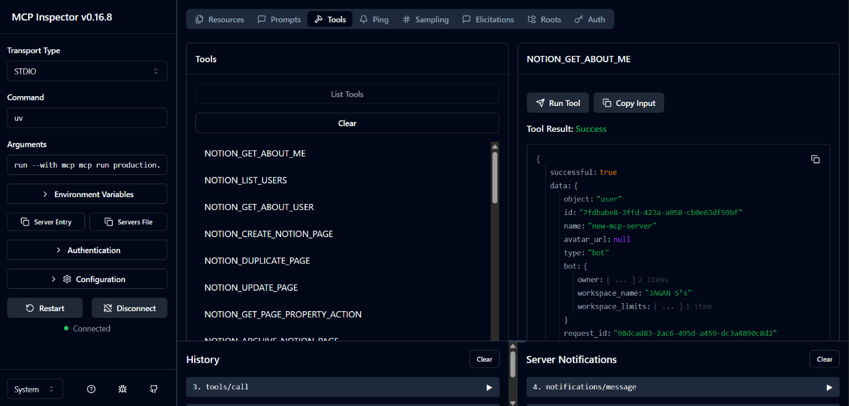

**NOTION_LIST_USERS**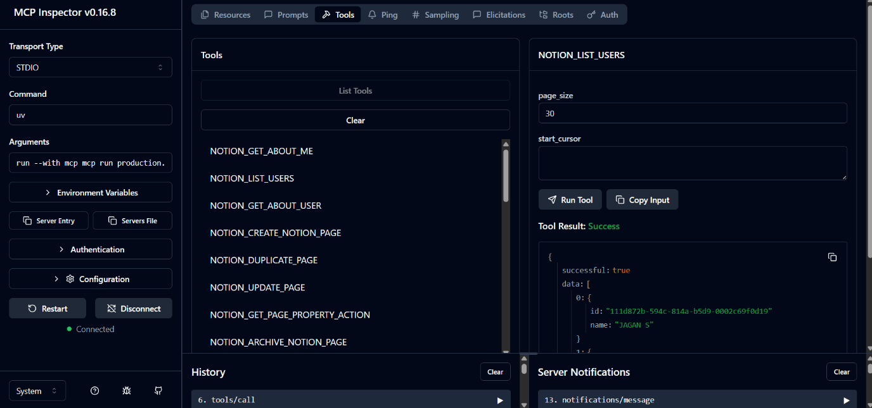

**NOTION_GET_ABOUT_USER**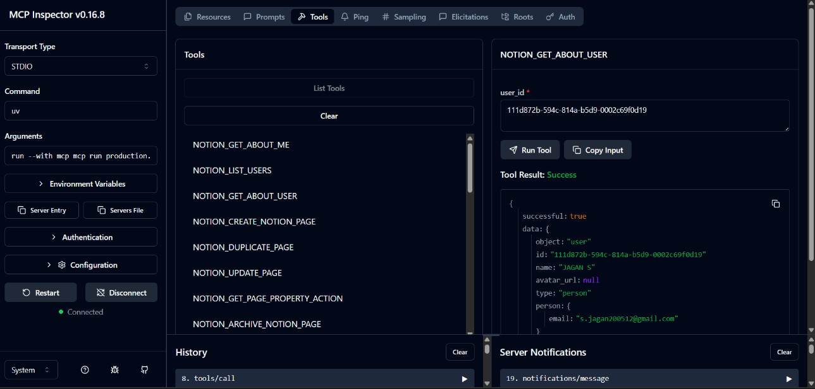

**OUTPUT :**

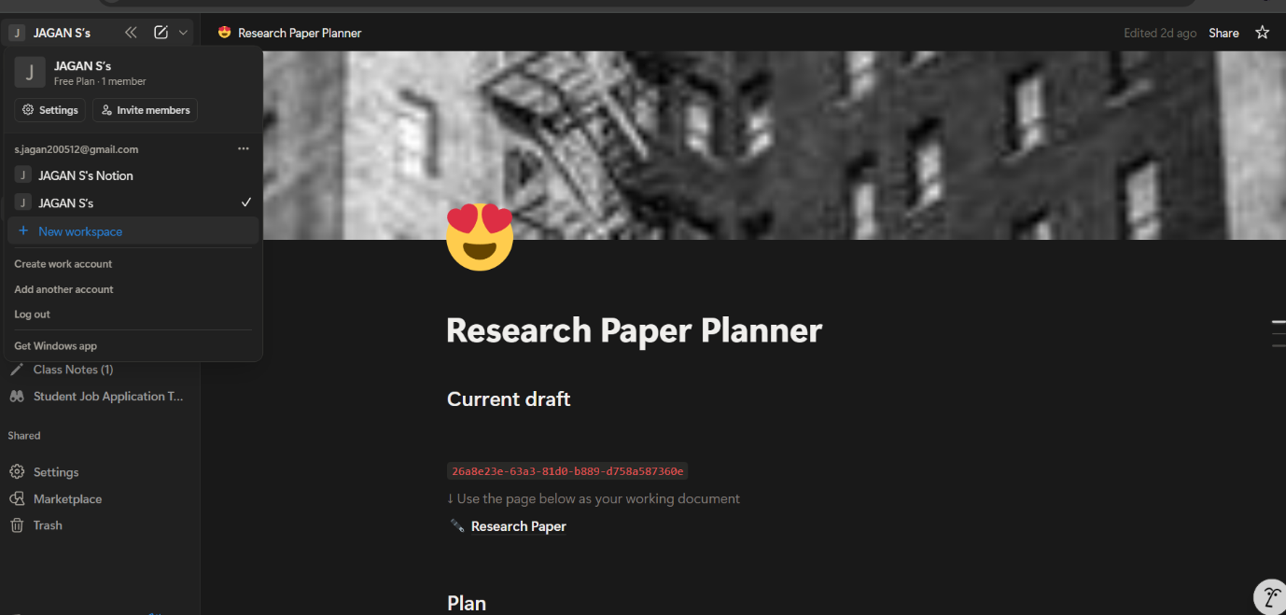

**NOTION_CREATE_NOTION_PAGE** 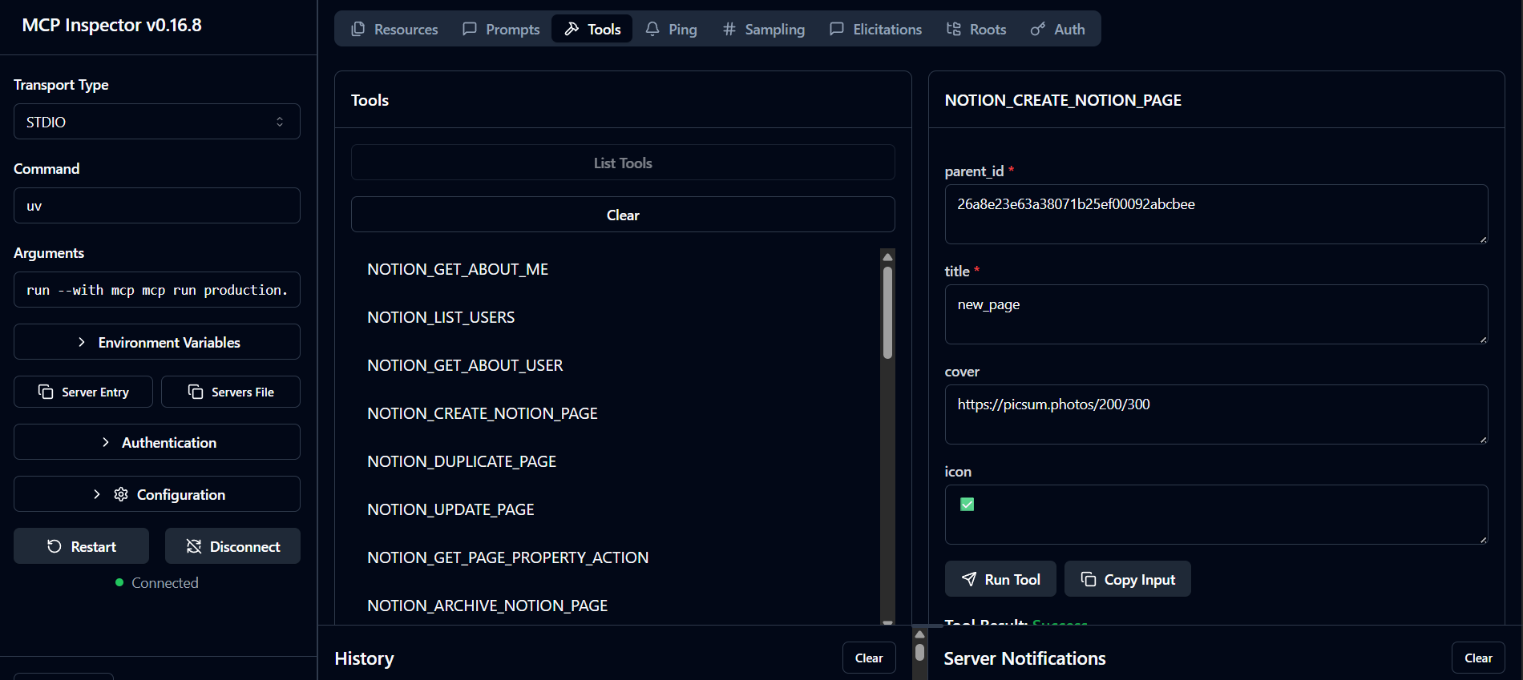

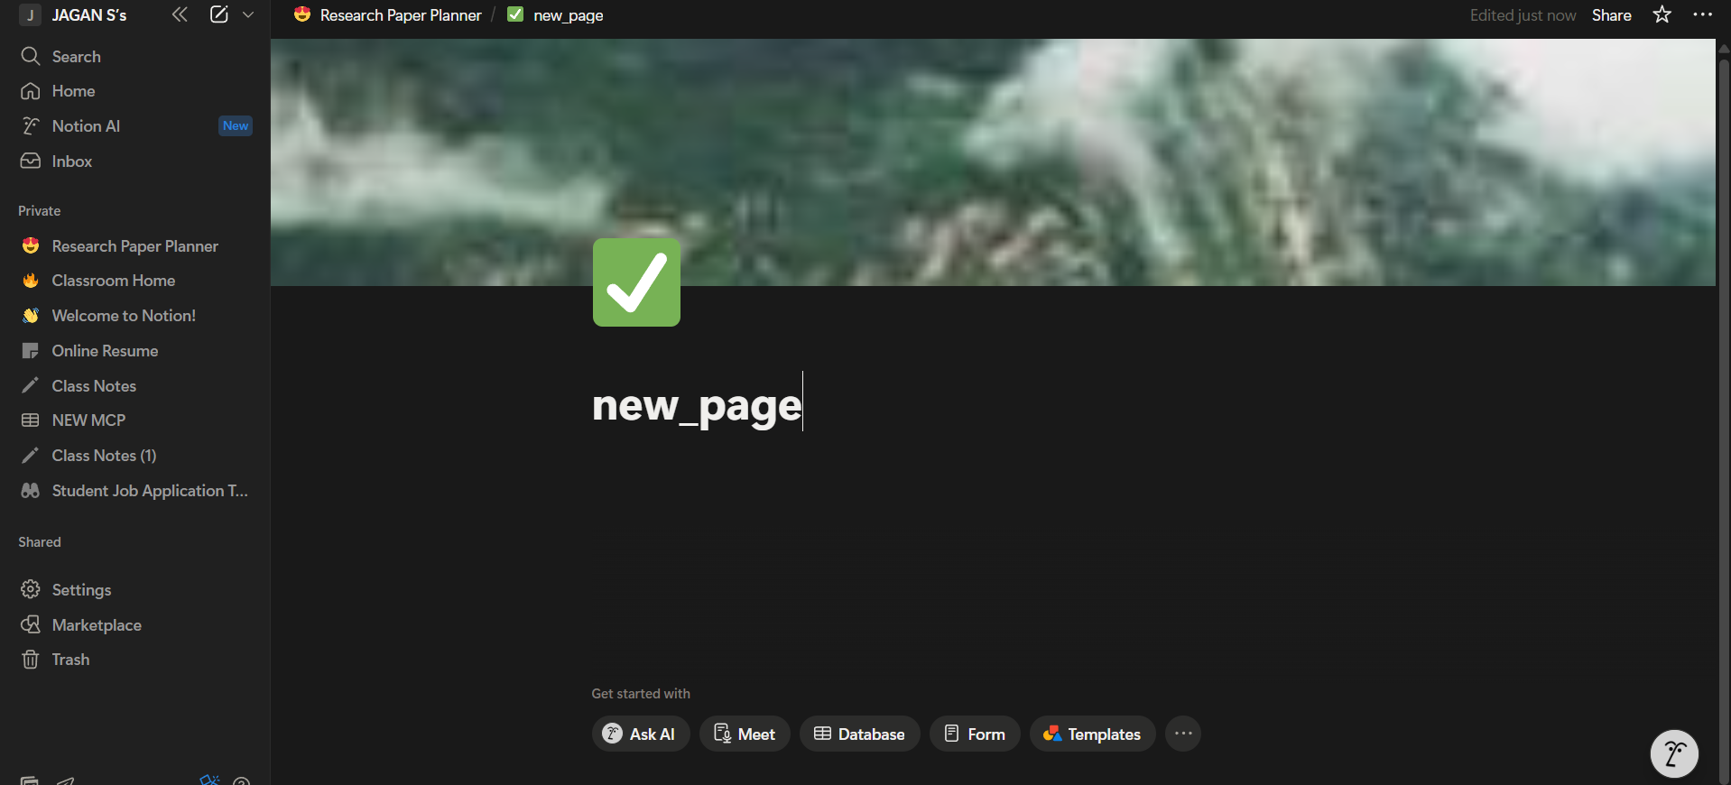

**NOTION_DUPLICATE_PAGE**

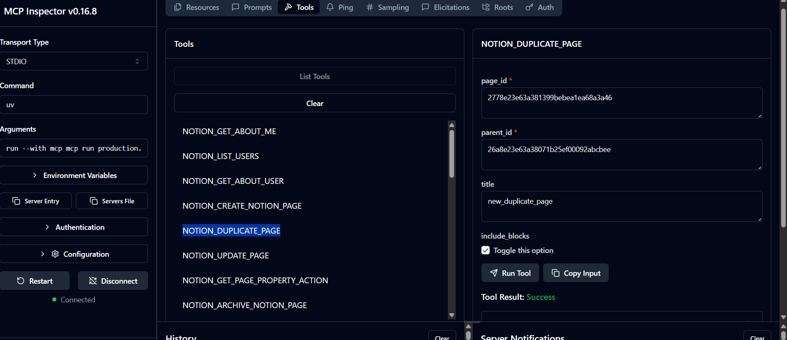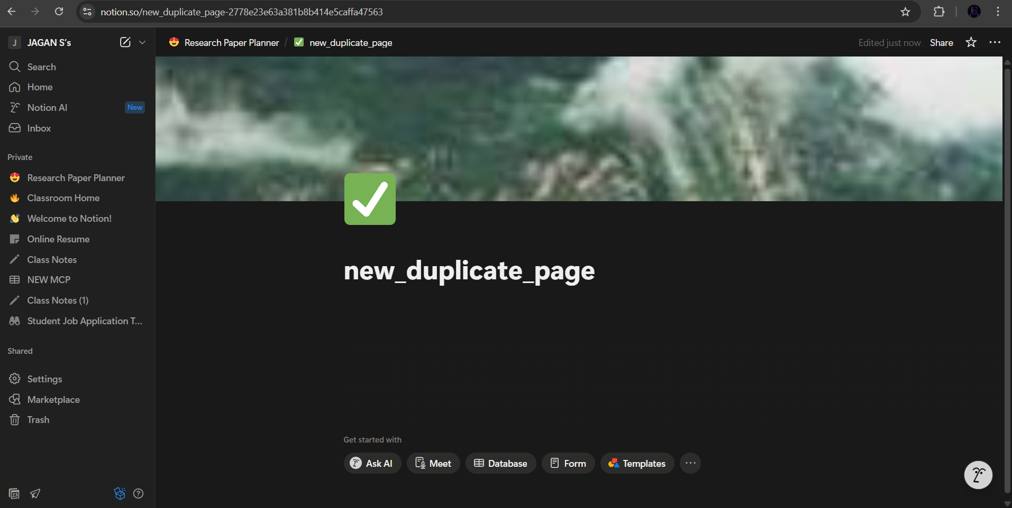

**NOTION_UPDATE_PAGE**

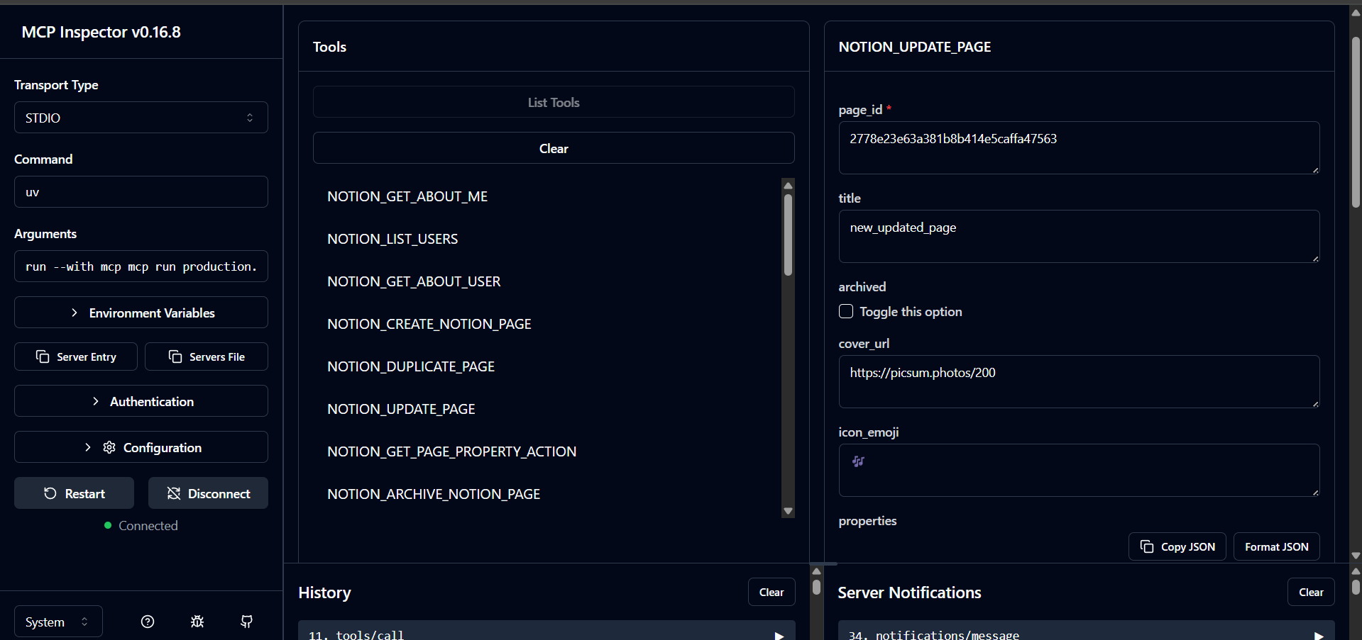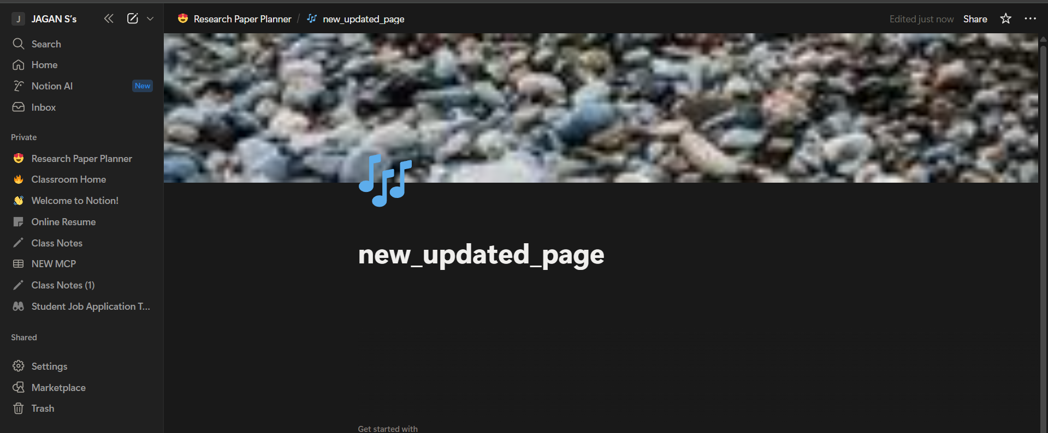

**NOTION_ARCHIVE_NOTION_PAGE**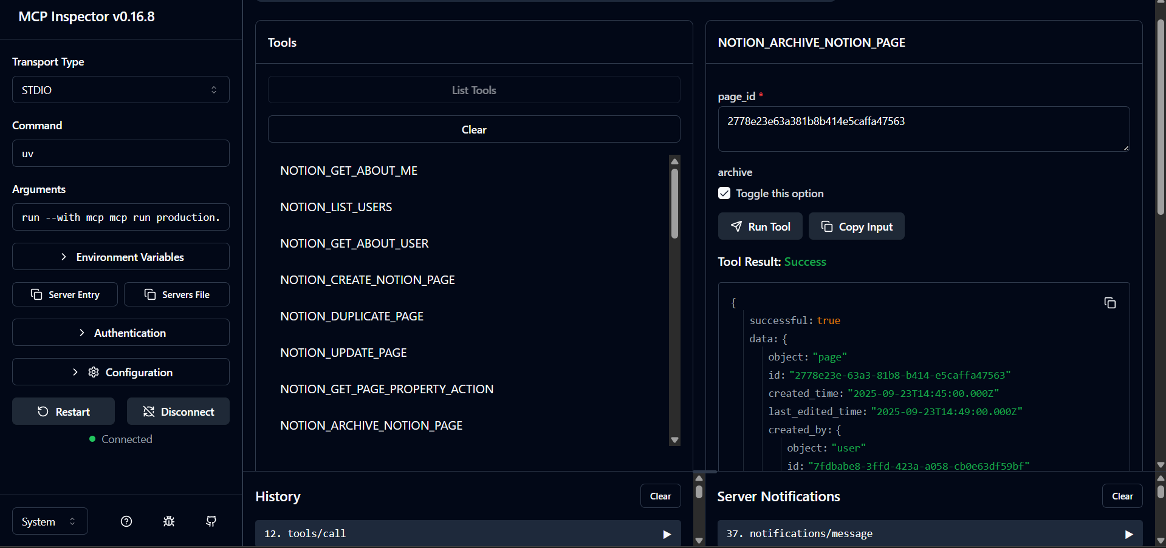

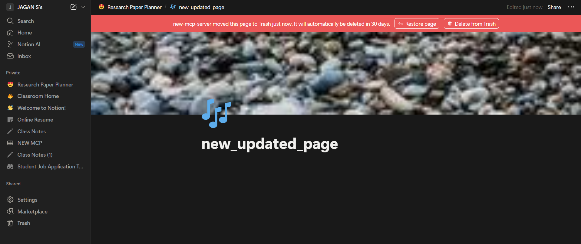

**NOTION_GET_PAGE_PROPERTY_ACTION**

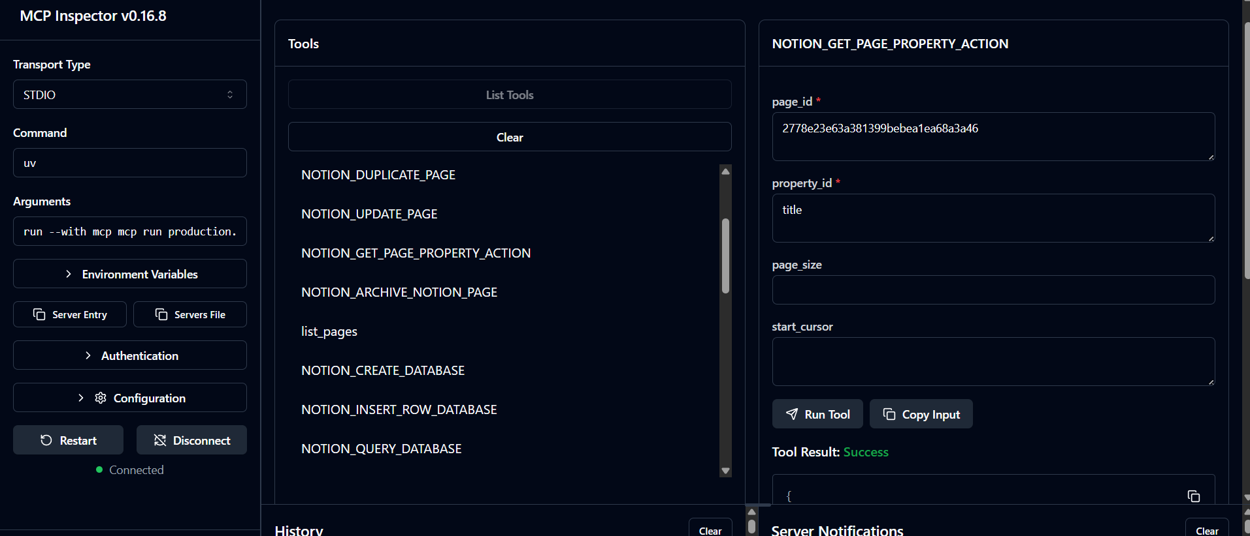

**list_pages**

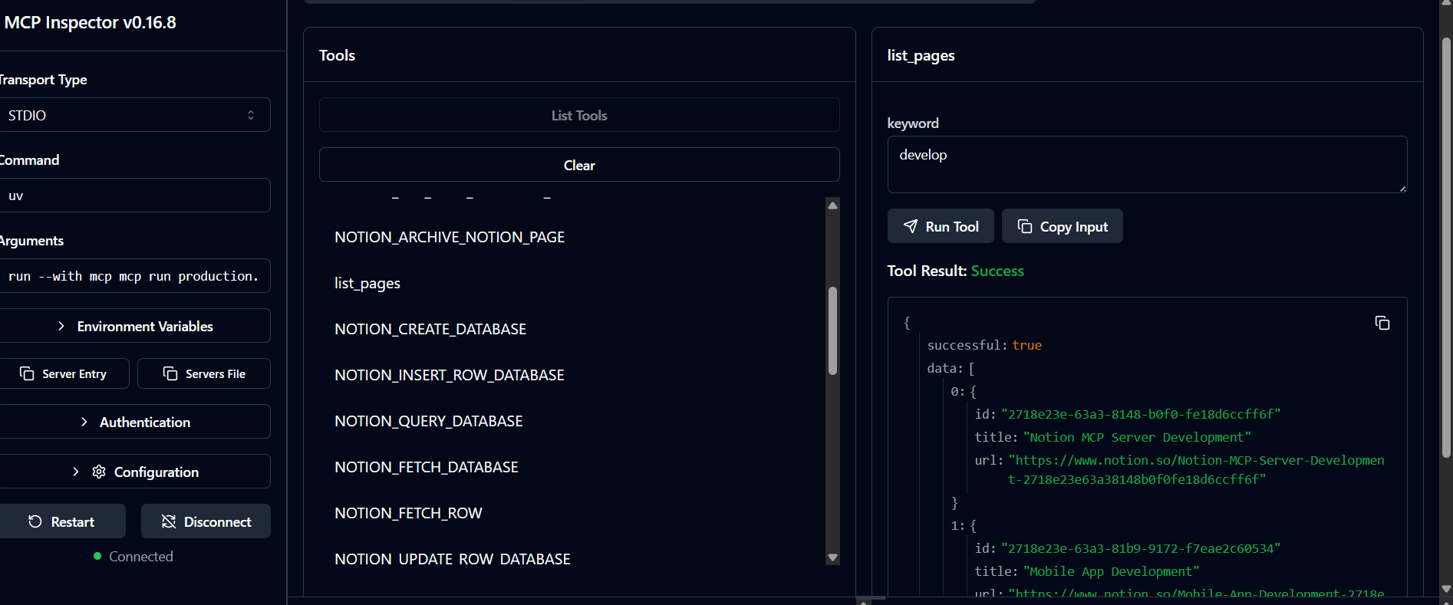

**NOTION_CREATE_DATABASE**

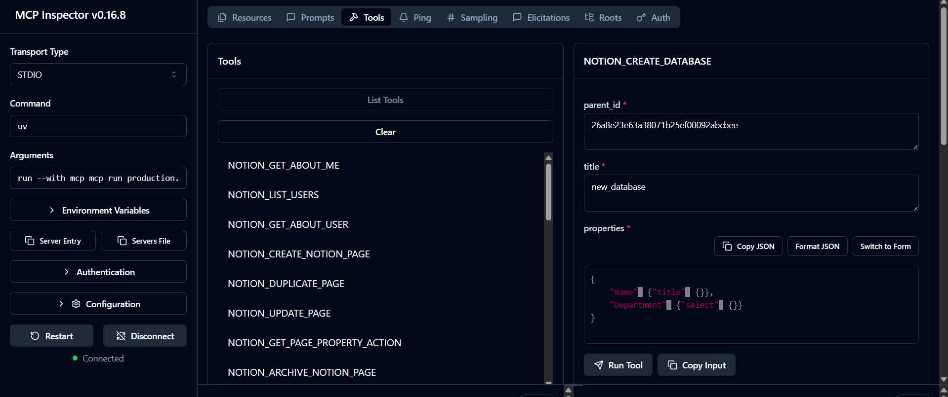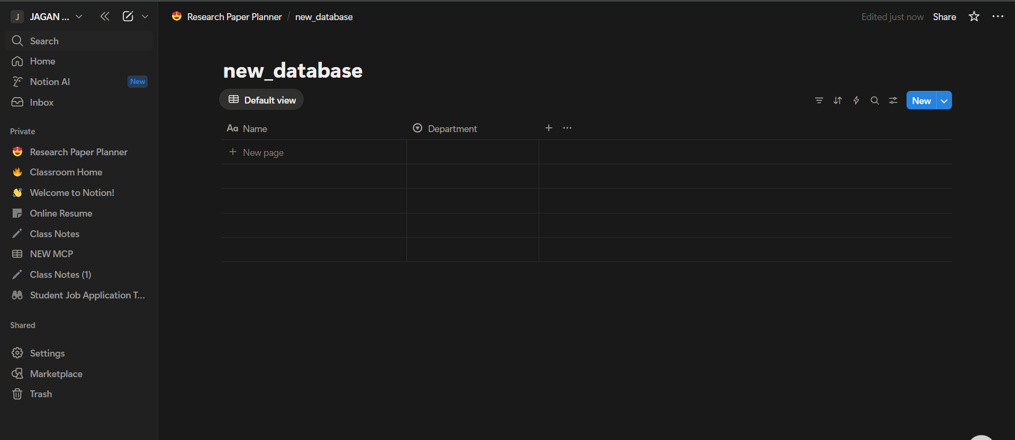

**NOTION_INSERT_ROW_DATABASE**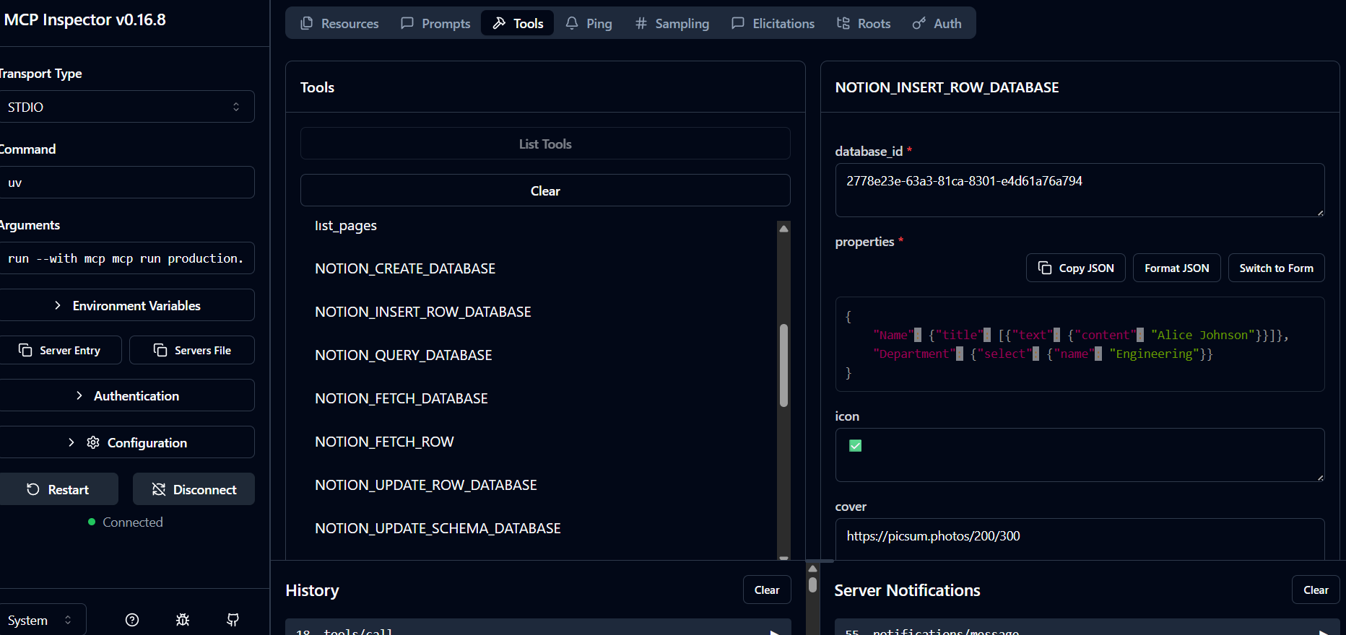

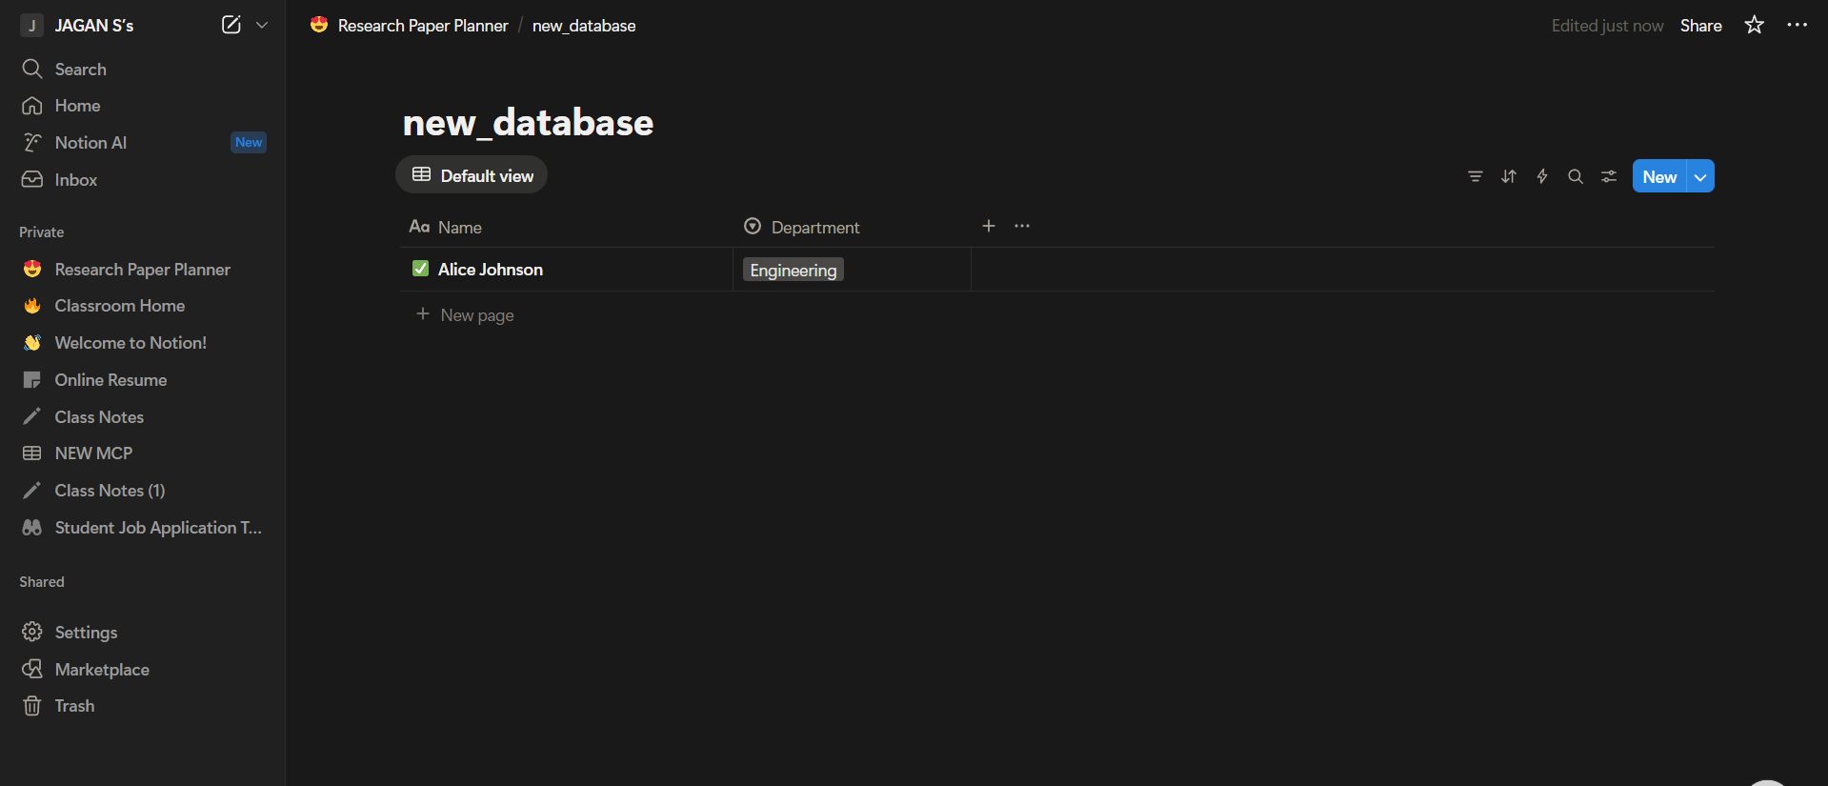

**NOTION_QUERY_DATABASE**

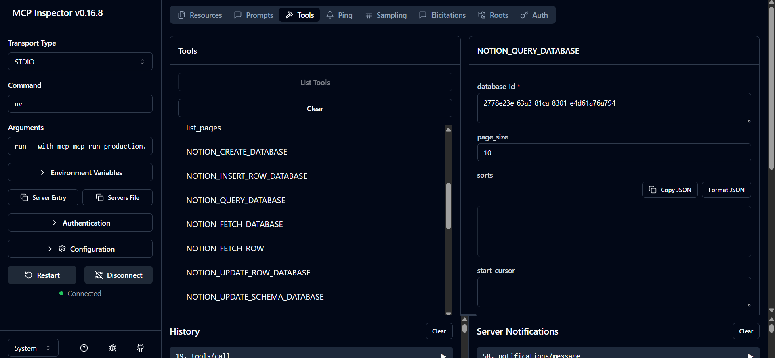

**NOTION_FETCH_DATABASE**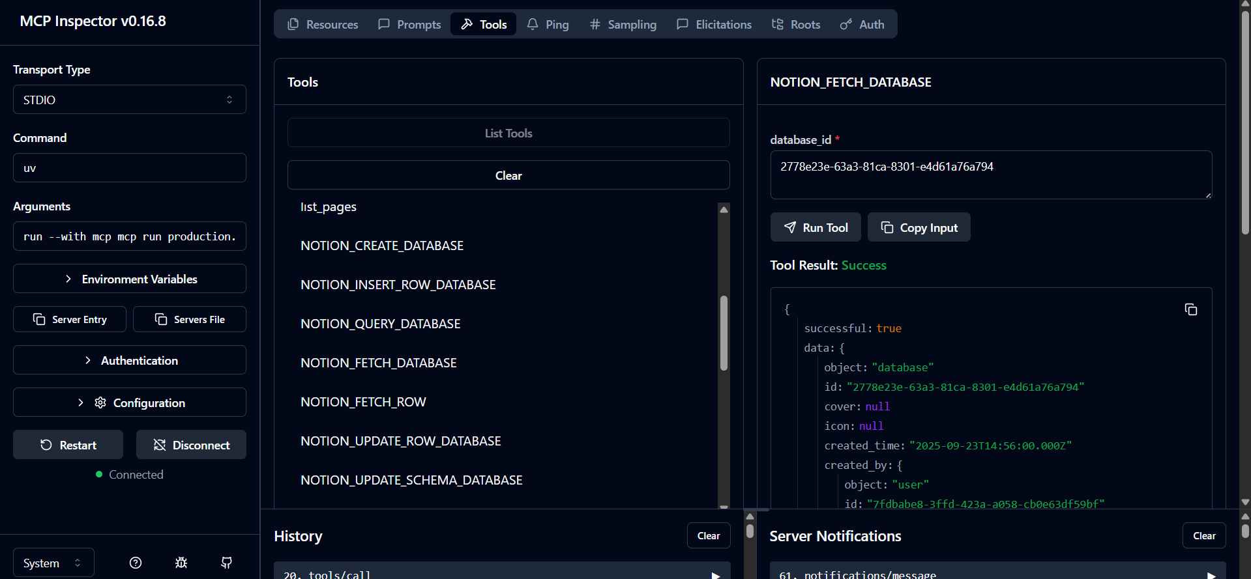

**NOTION_FETCH_ROW**

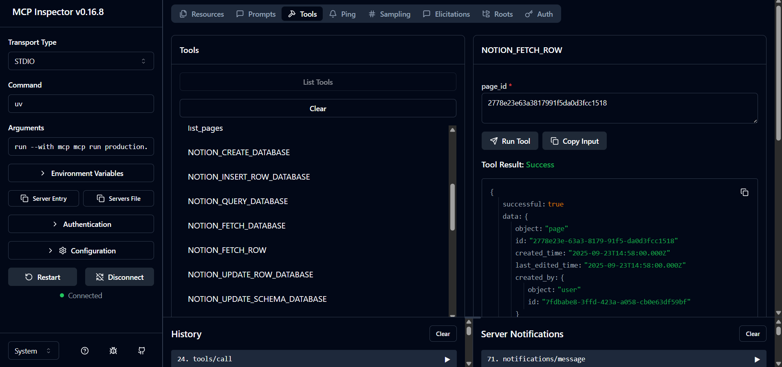

**NOTION_UPDATE_ROW_DATABASE**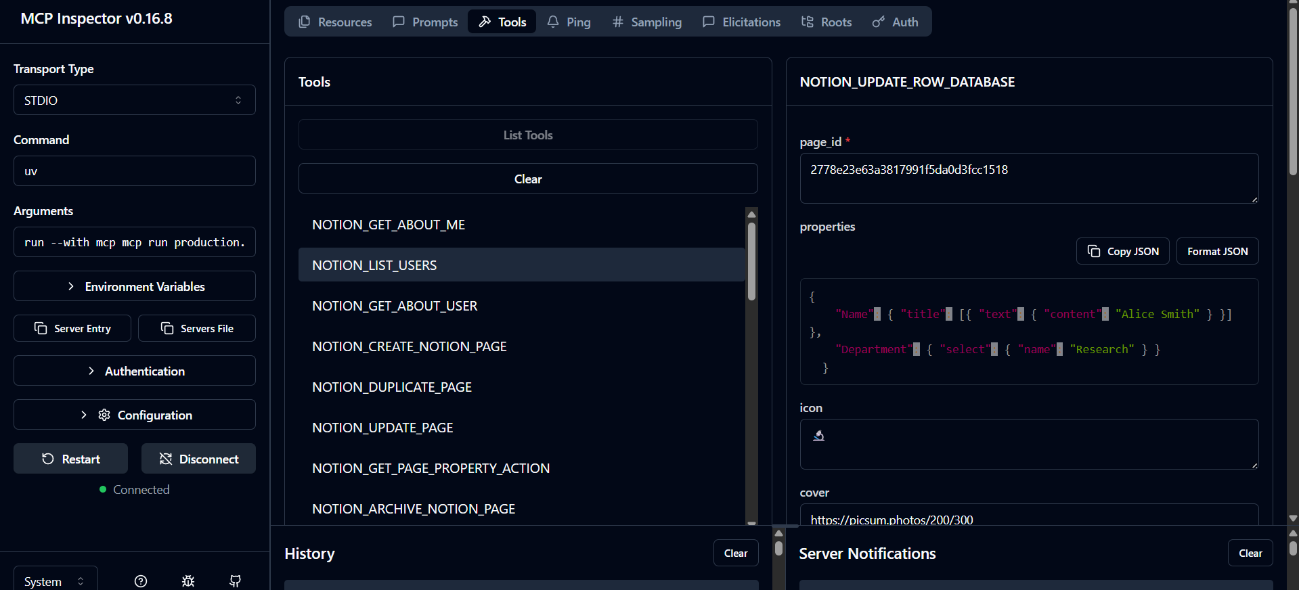

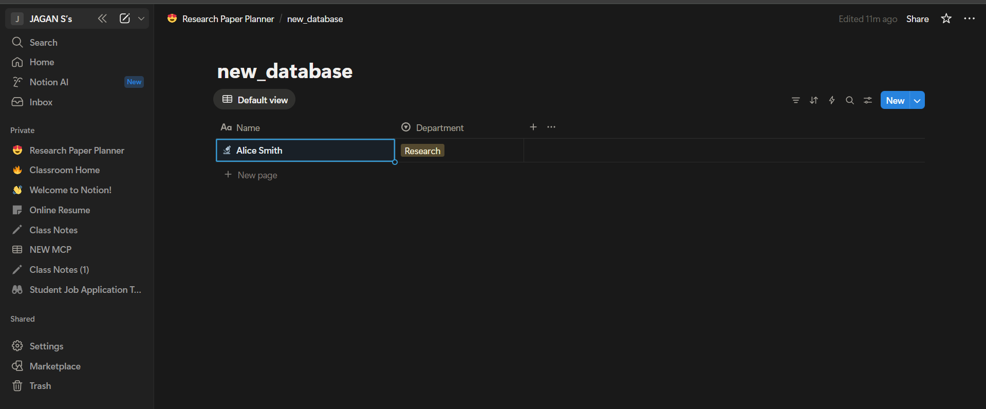

**NOTION_UPDATE_SCHEMA_DATABASE**

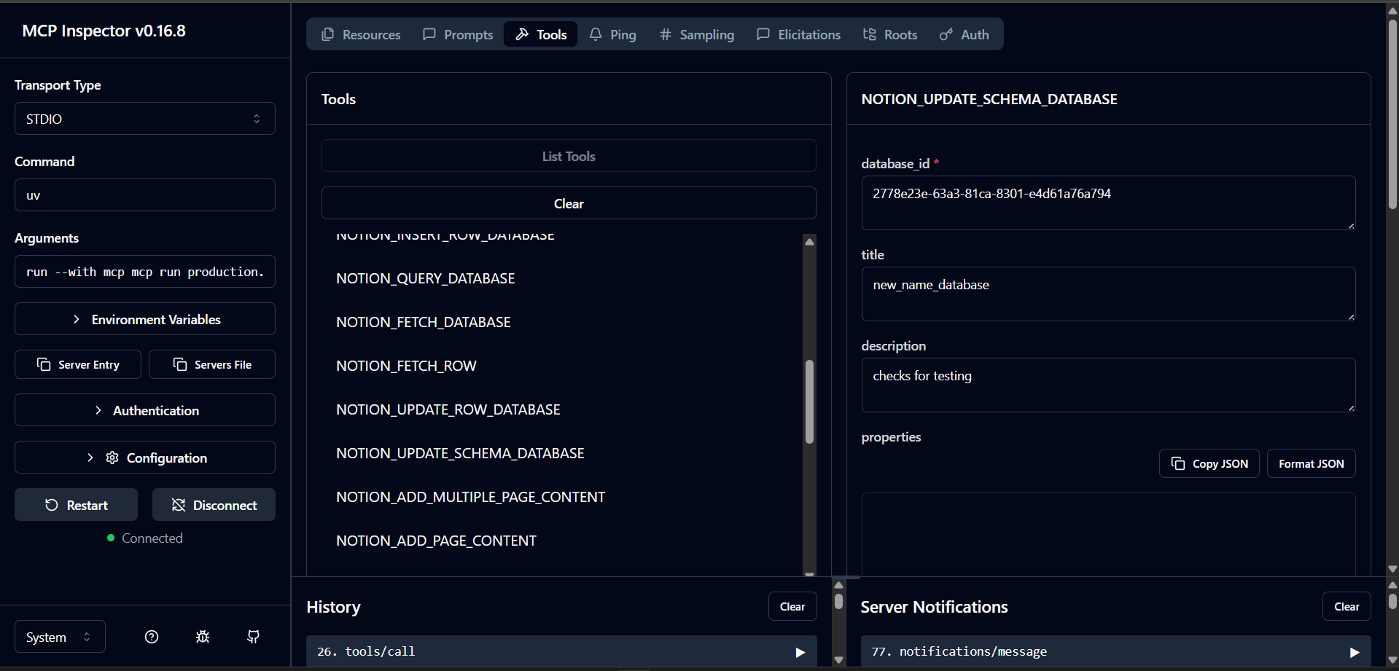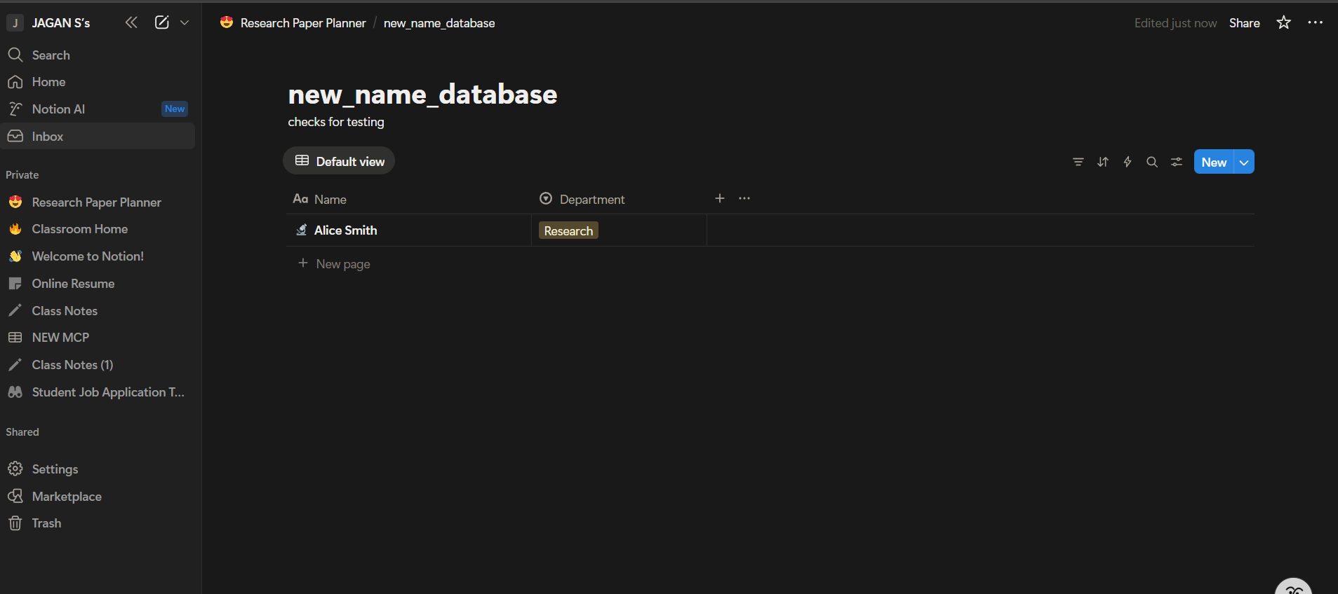

**mcp_notion_get_all_ids_from_name**

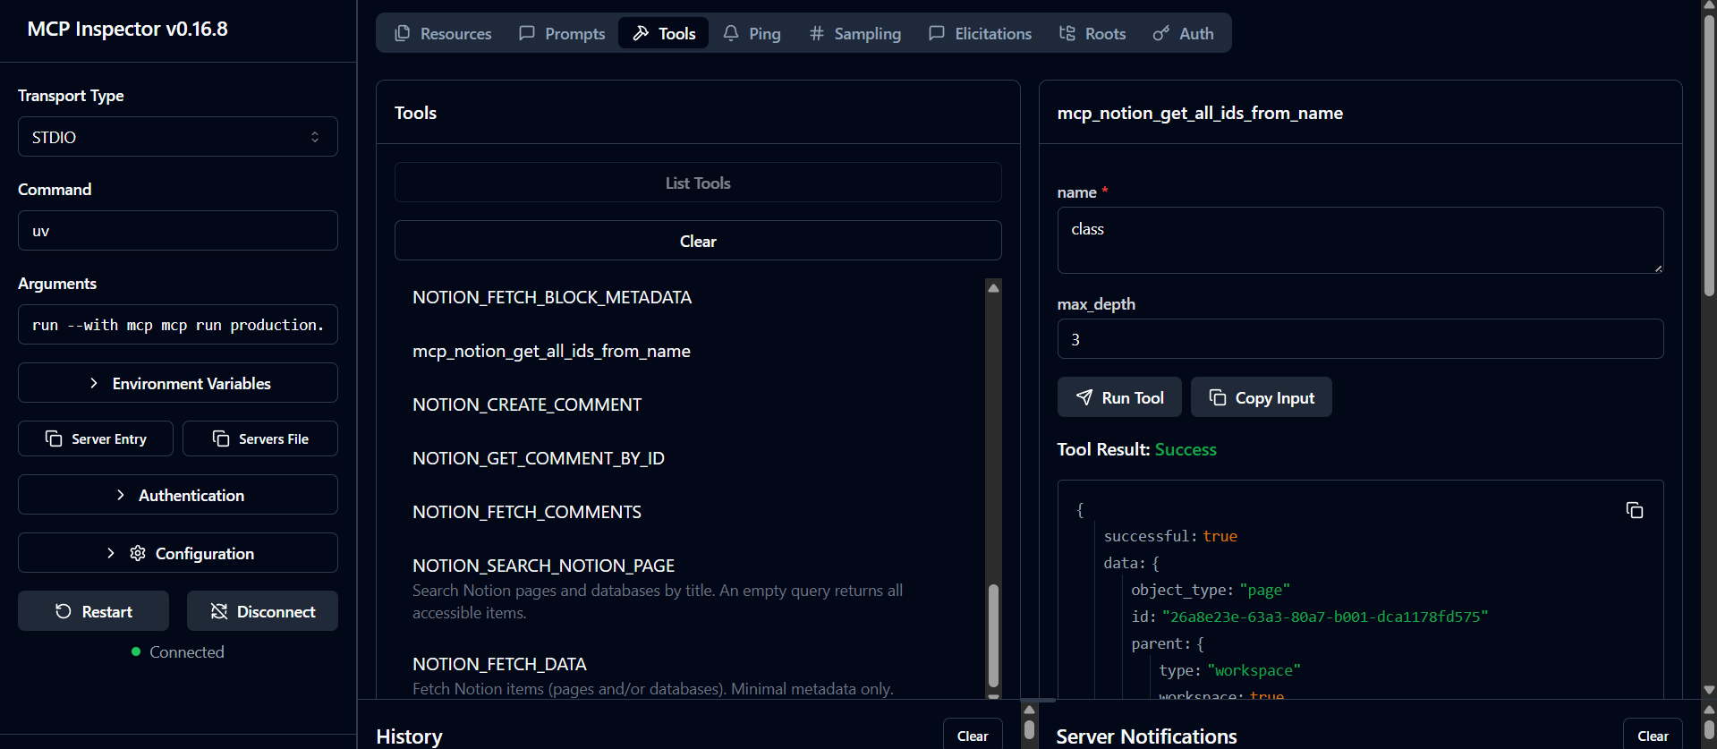

**NOTION_FETCH_DATA**

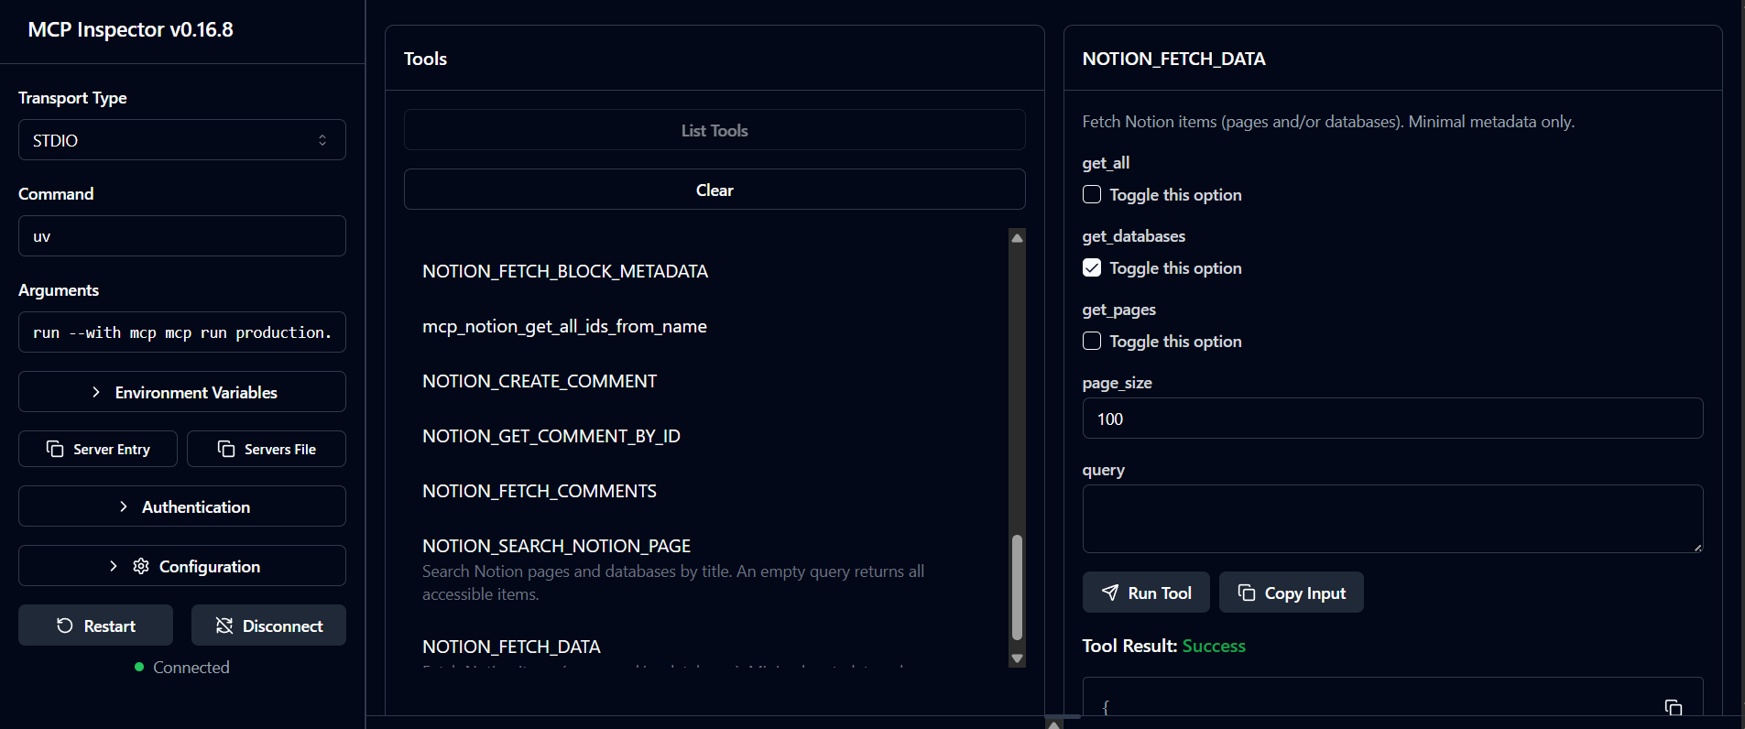

**NOTION_SEARCH_NOTION_PAGE**

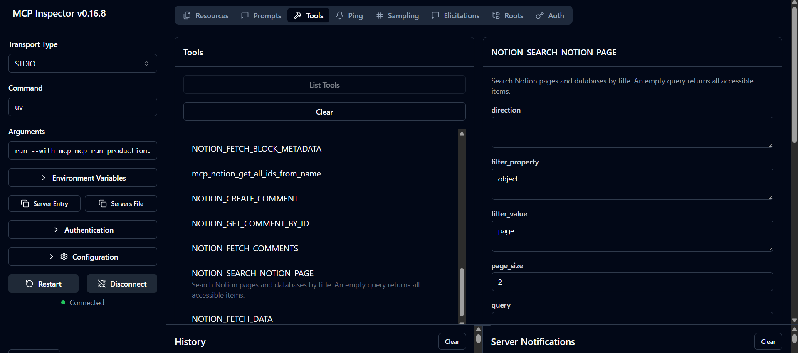

**NOTION_FETCH_BLOCK_CONTENTS**

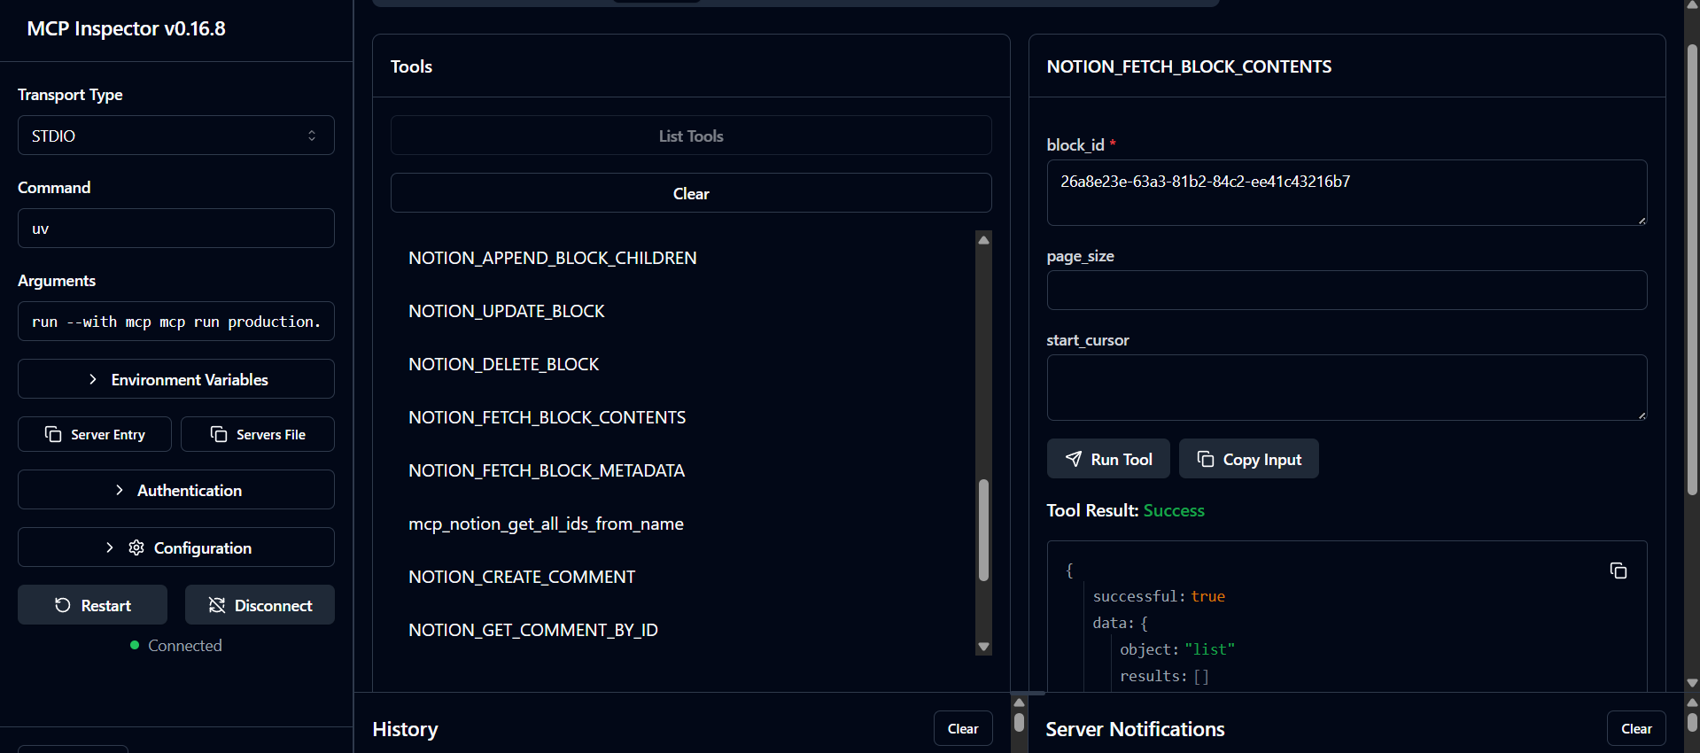

**NOTION_FETCH_BLOCK_METADATA**

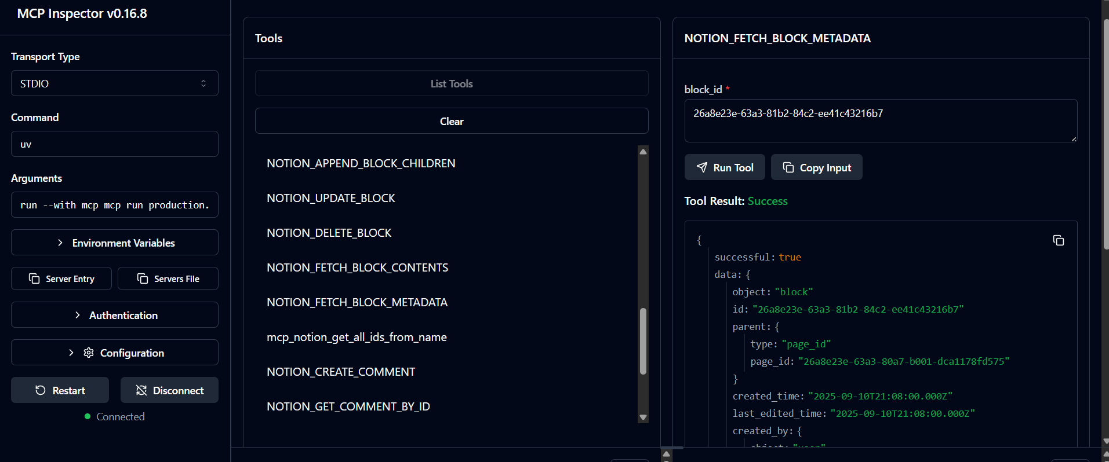

**NOTION_CREATE_COMMENT**

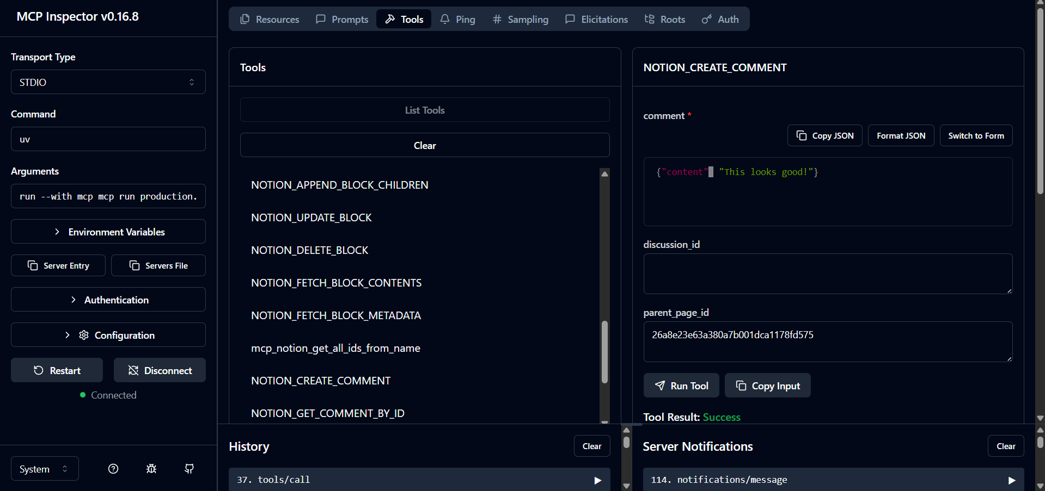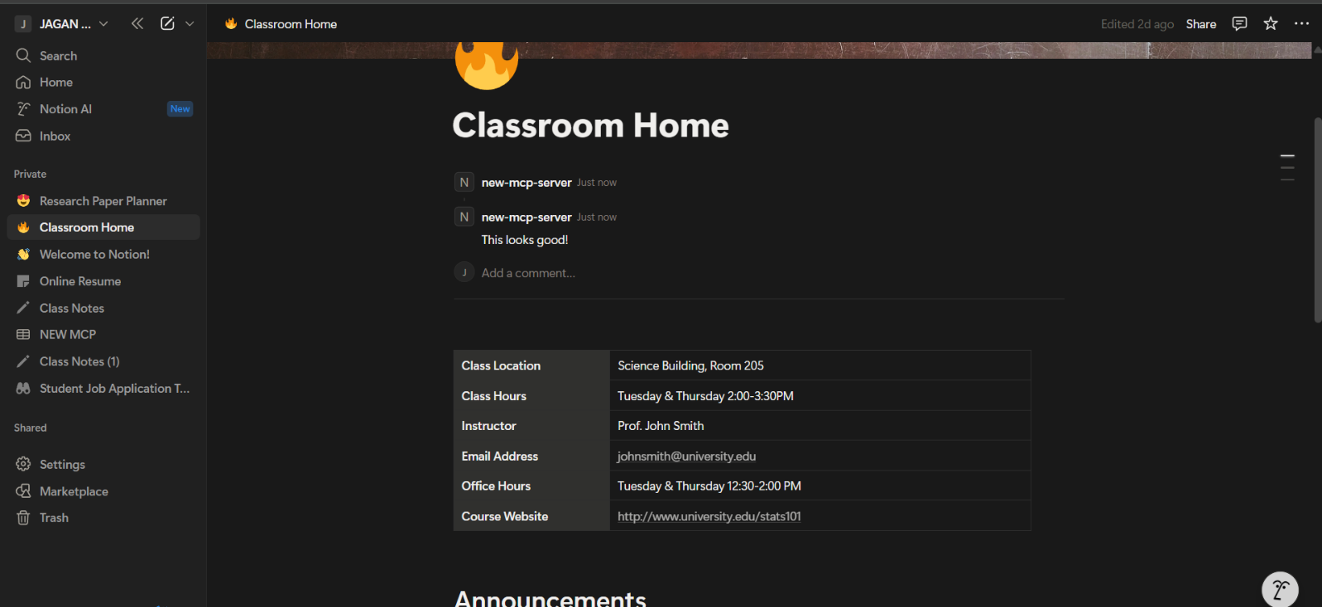

**NOTION_FETCH_COMMENTS**

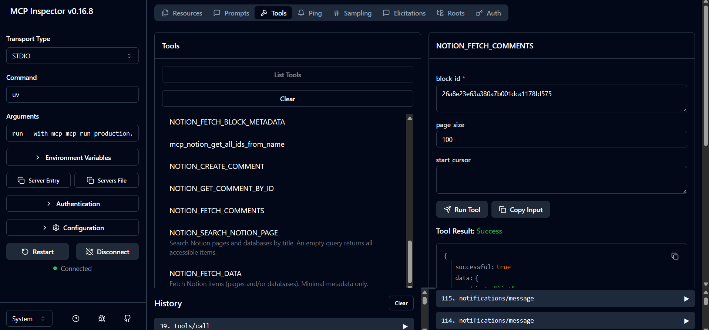

**NOTION_GET_COMMENT_BY_ID**

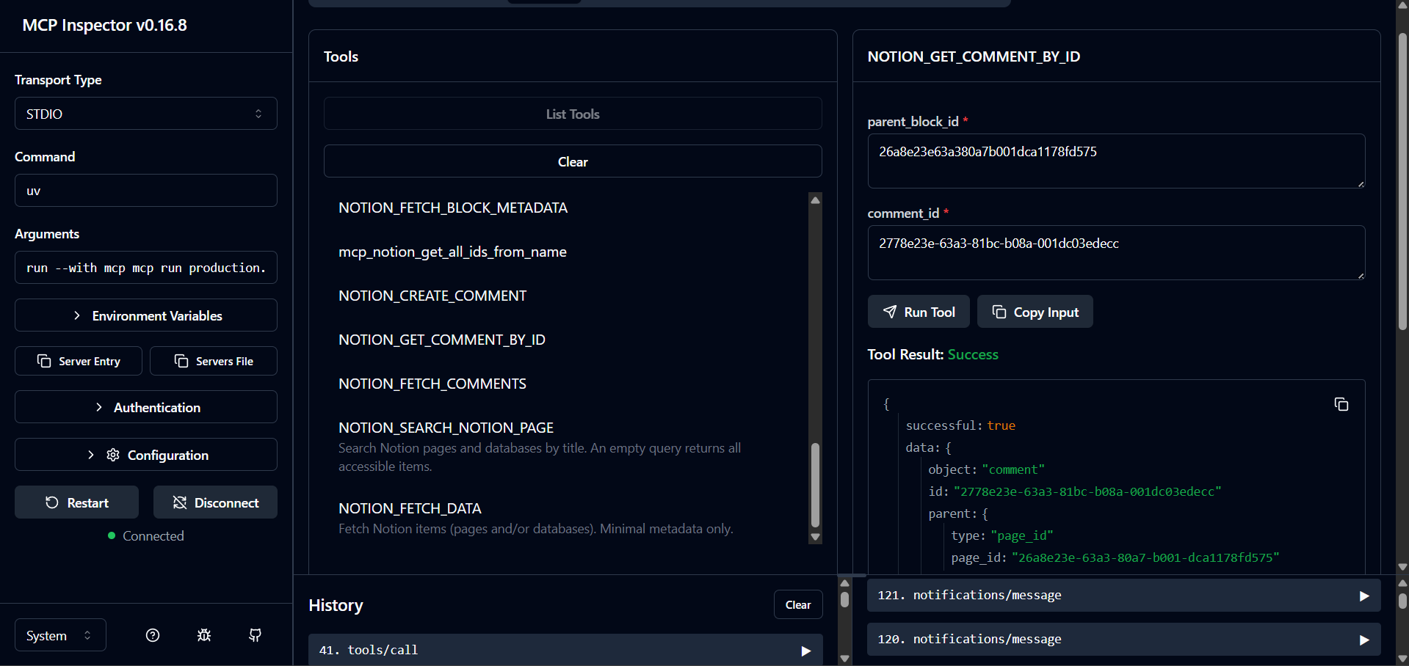

**NOTION_APPEND_BLOCK_CHILDREN**

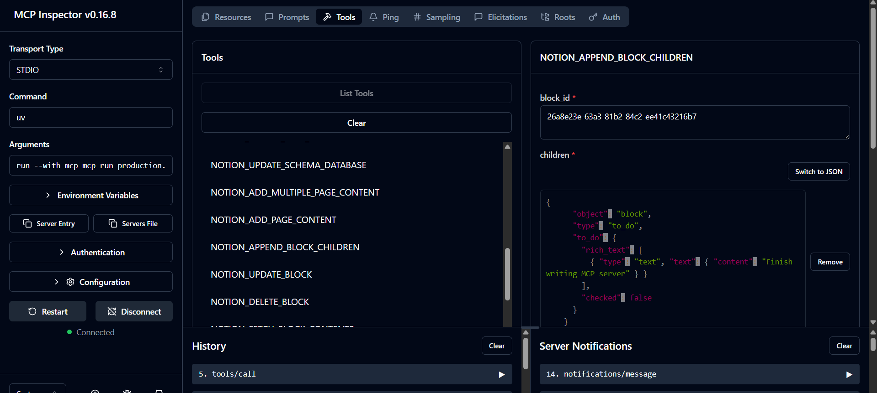

**NOTION_UPDATE_BLOCK**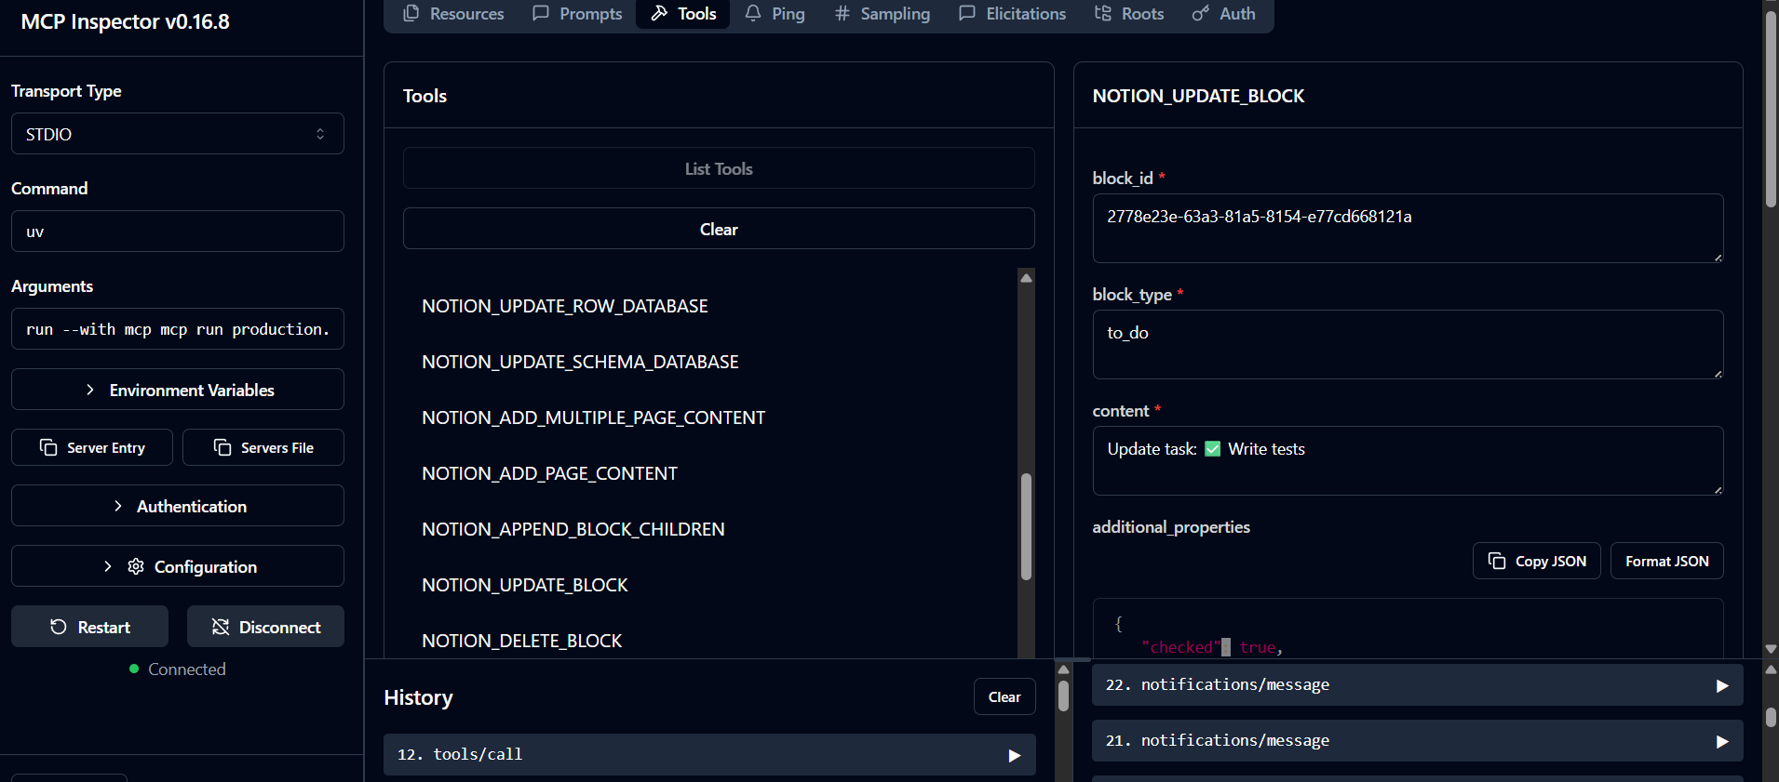

**NOTION_DELETE_BLOCK**

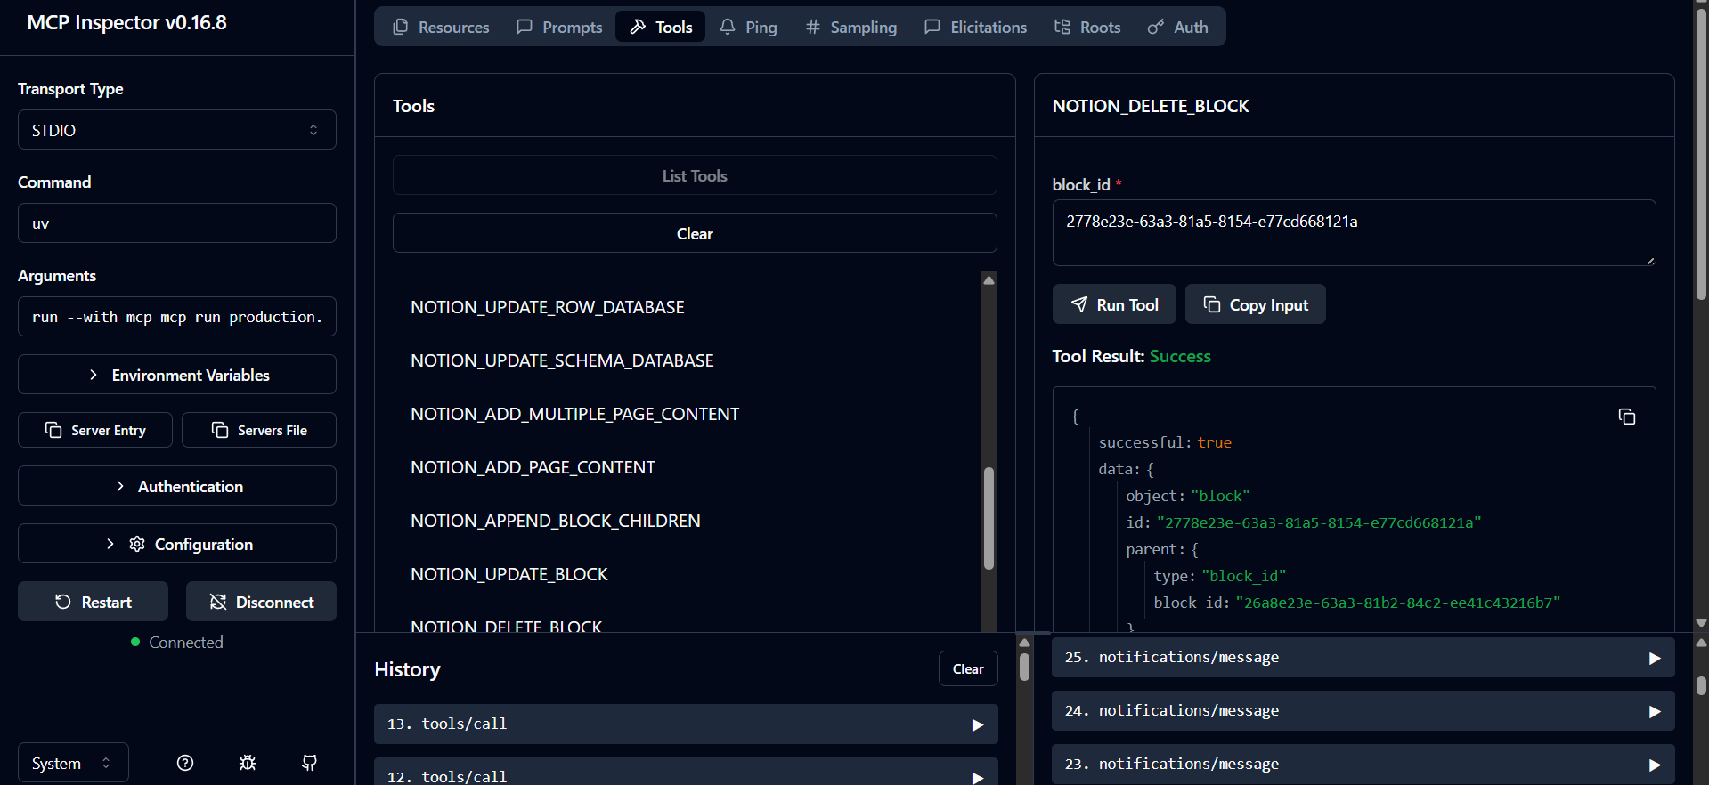

**NOTION_ADD_MULTIPLE_PAGE_CONTENT**

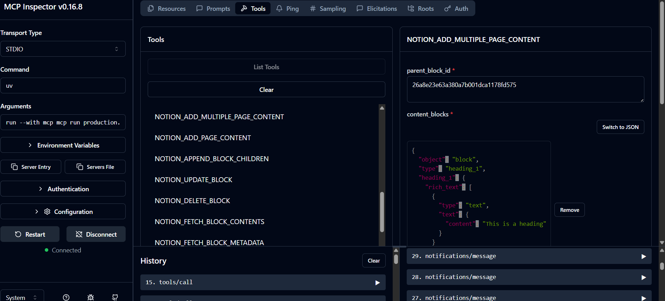

**NOTION_ADD_PAGE_CONTENT**

